**RIGGED ROBOTIC ARM**

*Created By- Jaskarandeep Singh – 102003486 -- 3COE19.*

IMAGES

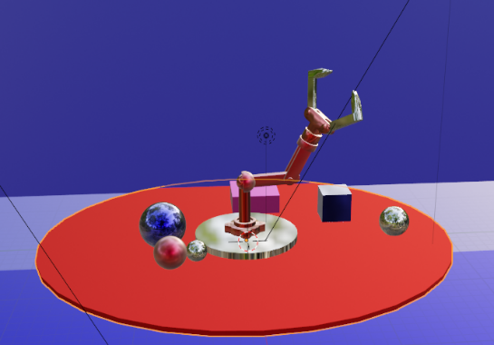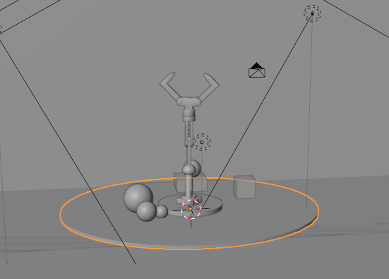

Basic model with viewport shader

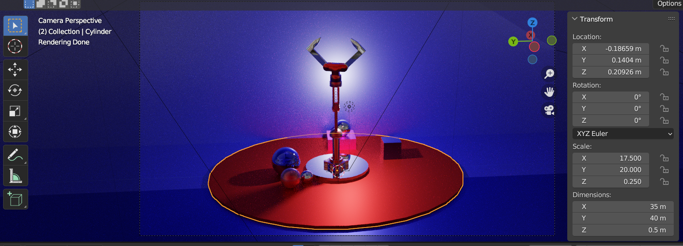

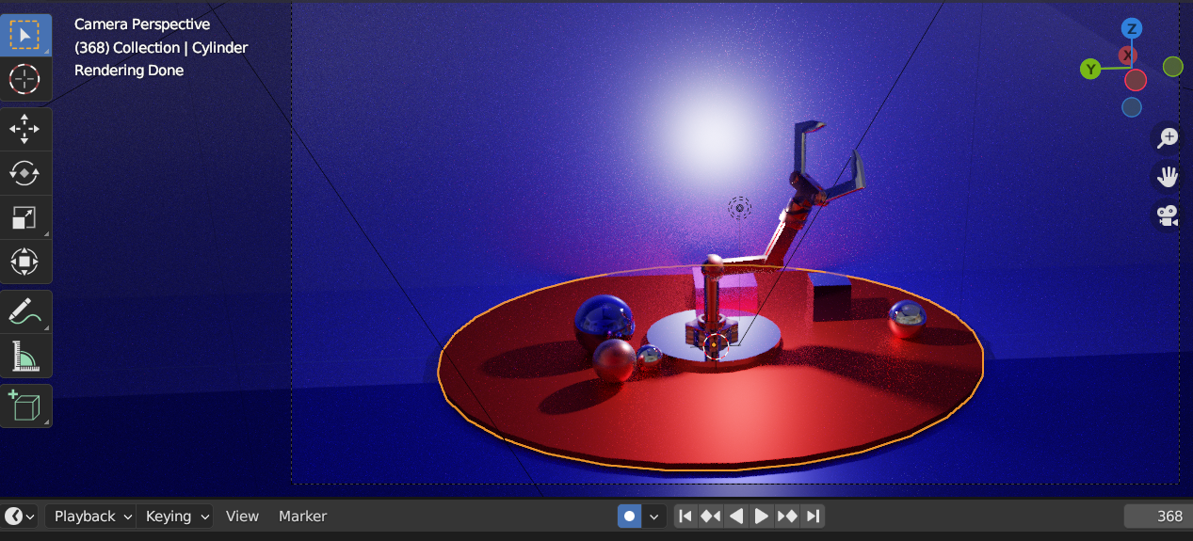

WITHOUT COLOR RAMP **USING TEXTURES(Unity version)**

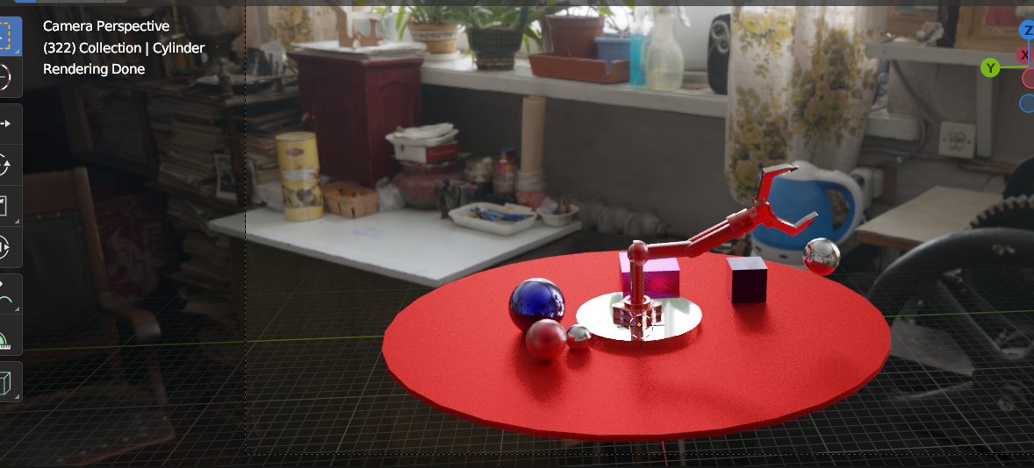

**TEXTURES**

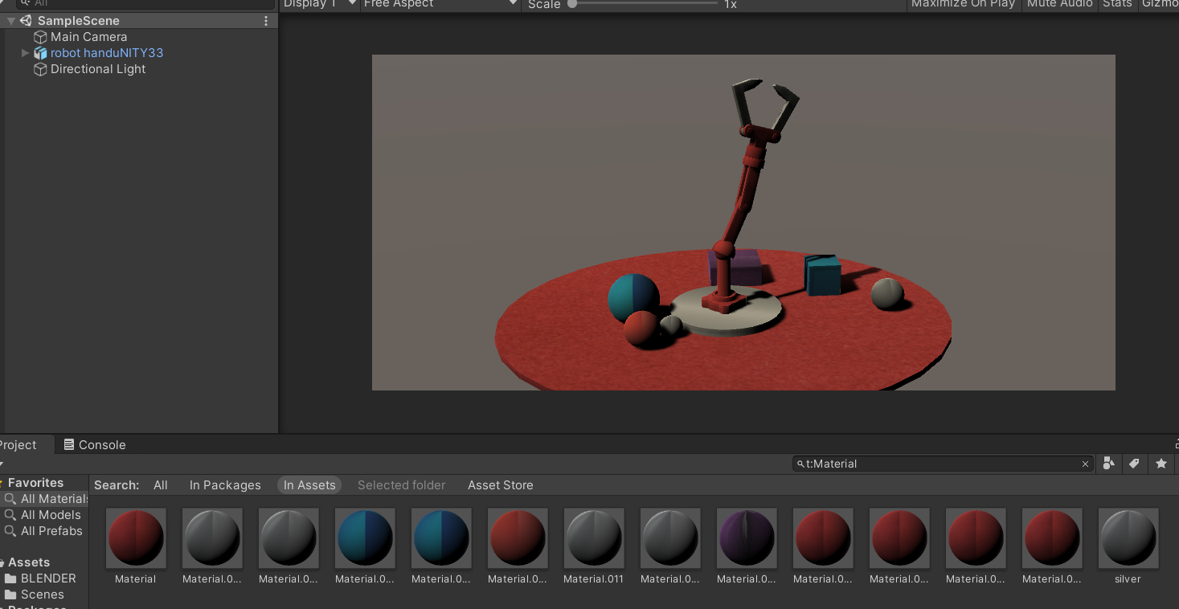

**Blender metallic reflections used here are not supported in unity(Hence only textures)**

STEPS:-

The Project is about Rigging (A rigged robotic Arm)

For the creation of the following particle system the steps involved were: -

1. Using primitive 3d shapes create a robotic arm (cubes, cylenders, Ico sphere).
2. Then perform rigging on the joints/moving objects of the robotic arm.
3. To perform rigging add rigging Points to the joints.
4. Connect each layer of the object.
5. Now as the object is rigged, now the arm can be moved across the joints.
6. The next task is to create an animation to show rigged object.
7. Start by frame 0 in the animations panel , click record button to record all the actions.
8. Keep on increasing the timeframe and giving a movement/rotation to the object/Arm.
9. Add world Scene to the background as an image.
10. Give a Background to the Rigged arm (Here a cube is used along with planes)
11. Add a lighting source (here a point source and 2 area lights are used)
12. Then Render the Animation (Max sample per frame – 80 for both viewport and

Render )(more the sample rate higher the quality but a significant increase in rendering time), and Save it.